Name Date
Stage 9 End of unit 9 test
1 Work out the first four terms of these sequences.
a first term 1 term-to-term rule is square, then add 2.

1st term: 1 2nd term: 3rd term:
4th term: [2]
b first term 6 term-to-term rule is subtract 3, then square.

1st term: 6 2nd term: 3rd term:
4th term: [2]
c first term is 4 term-to-term rule is add 1, add 3, add 5, …

1st term: 4 2nd term: 3rd term:
4th term: [2]
d first term is 22 term-to-term rule is subtract 2, subtract 4, subtract 6, …

1st term: 22 2nd term: 3rd term:
4th term: [2]
2 Complete the missing terms in these linear sequences.
a 2, , , , ,

[2]
b , , 19.2, 16, ,
9.6, , [2]
3 The third term of a sequence is 14. The term-to-term rule is: square, then subtract 11.
What is the first term of the sequence?

[3]
4 Work out the first three terms and the 10th term of the sequences with the given nth terms.
a 3n – 5
1st term: 2nd term:
3rd term: 10th term: [2]
b
1st term: 2nd term:
3rd term: 10th term: [2]
c n³ + 5
1st term: 2nd term:
3rd term: 10th term: [2]

5 Work out the nth term rules for these sequences. Show all of your working.
a 6, 9, 14, 21, 30, …
nth term is: [2]
b −6, −3, 2, 9, 18, …
nth term is: [2]
6 The cards A, B and C, show one term from three different sequences.
A 9th term in the sequence.
nth term is

B 6th term in the sequence.
nth term is

C 15th term in the sequence.
nth term is

a Work out the term for each card.

A term: B term: C term: [3]
b Write your answers to part a in order of size, starting with the smallest.

[1]
7 The nth term rule for a sequence is n² − 21. Is the number 204 a term in this sequence?
Explain your answer.

[2]
8 a Complete the table of values for each two-step function machine.
i
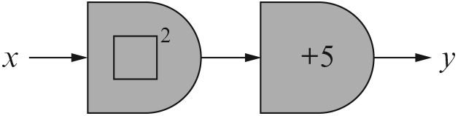

x | 1
y |  |  | 14

ii
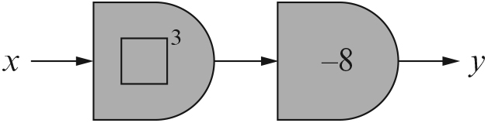

x | −1 | 2
y |  |  | 117 | 992
[4]
b Write each function in part a as an equation.
i ii [2]

9 For each of these function machines
i write down the equation
ii work out the reverse equation.
a
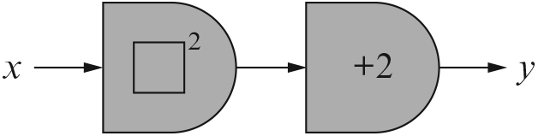
i ii
b
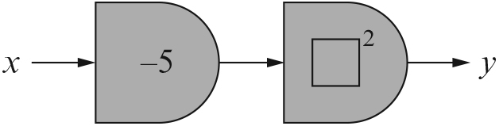
i ii
c
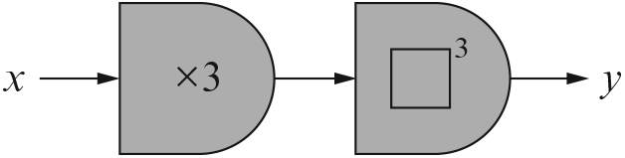
i ii
d
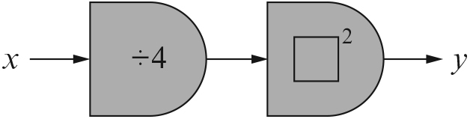
i ii [8]
[Total: 45 marks]

END OF TEST

